Healthcare facility organizational chart
Name
Institution
Course
Instructor
Date

Healthcare facility organizational chart
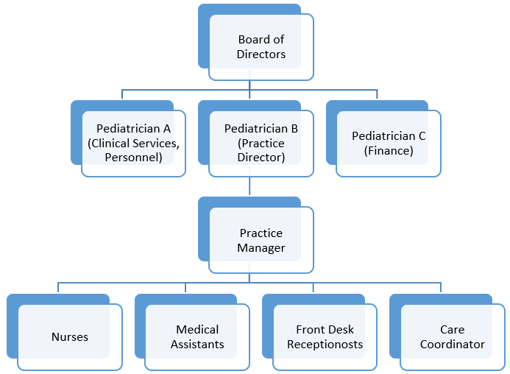
List of roles
Board of directors
The board of directors is responsible for the overall leadership of the facility. This includes decision-making and setting of management policies (Stefl, 2018).
Pediatrician A, B, C
Pediatrician A, B, and C represent the managers of different areas including clinical services, operations, and practice as well as finance. They are responsible for the overall management of each department.
Practice manager
The practice manager is the head of operations and practices carried out by the nurses, medical assistants, receptionists, and care coordinators. The practice manager is guided by the executive decisions made by the board of directors and pediatricians (Stefl, 2018).
Nurses
Nurses play various roles in the facility including assessment of patient needs, formulating the treatment plan for a patient, or diagnosing a disease (Taché, & Chapman, 2016)
Medical assistants
Medical assistants help in undertaking various clinical tasks such as taking a medical history of patients, recording patient's vital signs as well as assisting with administrative tasks in the care facility (Taché, & Chapman, 2016).
Front desk receptionists
The front desk receptionists are the gatekeepers of the healthcare facility. They are responsible for facilitating employee access, answering phone calls, scheduling appointments as well as managing the flow of individuals inside the organization. The reception is the first person one meets after getting into the facility (Hillis, Brenner, Larkin, Cawley, & Connolly, 2016).
Care coordinators
The role of care coordinators is to work with patients after hospital discharge in ensuring that they get to follow-up appointments, any extended therapy required as well as monitoring of the ongoing interventions (Hillis, Brenner, Larkin, Cawley, & Connolly, 2016). They work to reduce the risk of the resident's readmission to the hospital.

References
Hillis, R., Brenner, M., Larkin, P. J., Cawley, D., & Connolly, M. (2016). The role of care coordinator for children with complex care needs a systematic review. International journal of integrated care, 16(2).
Stefl, M. E. (2018). Common competencies for all healthcare managers: the healthcare leadership alliance model. Journal of healthcare management, 53(6).
Taché, S., & Chapman, S. (2016). What a medical assistant can do for your practice. Family practice management, 12(4), 51.

